**“The Dining Philosopher Problem  ”**

Raghav Sharma, Vaibhav Sabherwal, Sayeum Mahajan and Rassia Bharti

[2021a1r045@mietjammu.in](mailto:2021a1r045@mietjammu.in)

[2021a1r048@mietjammu.in](mailto:2021a1r048@mietjammu.in)

[2021a1r034@mietjammu.in](mailto:2021a1r034@mietjammu.in)

[2022a1l010@mietjammu.in](mailto:2022a1l010@mietjammu.in)

Model Institute of Engineering and Technology, CSE department, Kot Bhalwal,Jammu,

Jammu and Kashmir 181122

**ABSTRACT**

The Dining Philosophers problem is a classic case study in the synchronization of concurrent

processes and this research describes how to avoid deadlock condition in dining philosophers problem. [2]Dining itself is a situation where five philosophers sit at a circular table with a large bowl of spaghetti in the centre. A fork is placed in between each pair of adjacent philosophers, and as such, each philosopher has one fork to his left and one fork to his right. As spaghetti is difficult to serve and eat with a single fork, it is assumed that a philosopher must eat with two forks. Each philosopher can only use the forks on his immediate left and immediate right. The philosophers never speak to each other, which creates a dangerous possibility of deadlock when every philosopher holds a left fork and waits perpetually for a right fork (or vice versa).To resolve this condition semaphore[1] variable is used. It is marked as in a circular waiting state. At first, most people wear concepts simple synchronization is supported by the hardware, such as user or user interrupt routines that may have been implemented by hardware. In 1967, Dijkstra proposed a concept wearer an integer variable to count the number of processes that are active or who are inactive. This type of variable is called semaphore. The mostly semaphore also be used to synchronize the communication between devices in the device. In this journal, semaphore used to solve the problem of synchronizing dining philosophers problem.This paper presents the efficient distributed deadlock avoidance scheme using lock and release method that prevents other thread in the chain to make race condition[3].

**Problem Statement –**

Five philosopher dine together at the same table. Each philosopher has their own place at the table[2] There is a fork between each plate. The dish served is a kind of spaghetti which has to be eaten with two forks. Each philosopher can only alternately think and eat. Moreover, a philosopher can only eat their spaghetti when they have both a left and right fork. Thus two forks will only be available when their two nearest neighbours are thinking, not eating. After an individual philosopher finishes eating, they will put down both forks. The problem is how to design a regimen (a concurrent algorithm) such that no philosopher will starve; *i.e.*, each can forever continue to alternate between eating and thinking, assuming that no philosopher can know when others may want to eat or think (an issue of incomplete information).

**Problem**

**Description:**

Dining Philosophers Problem in OS is a classical synchronisation problem in the operating system[1]. With the presence of more than one process and limited resources in the system the synchronisation problem arises. If one resource is shared between more than one process at the same time then it can lead to data inconsistency. According to the Dining Philosopher Problem, assume there are K philosophers seated around a circular table, each with one chopstick between them. This means, that a philosopher can eat only if he/she can pick up both the chopsticks next to him/her. One of the adjacent followers may take up one of the chopsticks, but not both. The solution to the process synchronisation problem is Semaphores, A semaphore is an integer used in solving critical sections. The critical section is a segment of the program that allows you to access the shared variables or resources. In a critical section, an atomic action (independently running process) is needed, which means that only single process can run in that section at a time.

**Objectives:**

From time to time, a philosopher gets hungry and tries to pick up the two chopsticks that are closest to her (the chopsticks that are between her and her left and right neighbours).

A philosopher may pick up only one chopstick at a time.

Obviously, she cannot pick up a chopstick that is already in the hand of a neighbour.

When a hungry philosopher has both her chopsticks at the same time, she eats without releasing her chopsticks.

When she is finished eating, she puts down both of her chopsticks and starts thinking again.

It is a simple representation of the need to allocate several resources among several processes in a deadlock- and starvation free manner.

One simple solution is to represent each chopstick by a semaphore.

A philosopher tries to grab the chopstick by executing a wait operation on that semaphore[1]; she releases her chopsticks by executing the signal operation on the appropriate semaphores.

**Algorithm:**

[4]philosopher int P[5] ;

While ( TRUE )

{

……!?!?!........; /*Thinking*/

P ( fork [j] ) ; /*Pick up left fork*/

P ( fork [i+1] mod 5 ) ; /*Pick up right fork */

eat ( ) ;

V ( fork [i] ) ;

}

}

Philosopher 4 ( ) {

While ( TRUE ) {

……/*Thinking*/

P ( fork [0] ) ; /*Pick up right fork*/

P ( fork [4] ) ; /*Pick up  left fork*/

eat( ) ;

V ( fork [4] ) ;

V ( fork [0] ) ;

}

}

Semaphore fork [5] = {1, 1, 1, 1, 1};

fork (philosopher), 1, 0) ;

fork (philosopher), 1, 1) ;

fork (philosopher), 1, 2) ;

fork (philosopher), 1, 3) ;

fork (philosopher), 4, 0) ;

**Solution:**

A solution of the Dining Philosophers Problem is to use a semaphore to represent a chopstick. A chopstick can be picked up by executing a wait operation on the semaphore and released by executing a signal semaphore.

The structure of the chopstick is shown below −

semaphore chopstick [5];

Initially the elements of the chopstick are initialized to 1 as the chopsticks are on the table and not picked up by a philosopher.

The structure of a random philosopher i is given as follows −

do {

wait( chopstick[i] );

wait( chopstick[ (i+1) % 5] );

. .

. EATING THE RICE

.

signal( chopstick[i] );

signal( chopstick[ (i+1) % 5] );

.

. THINKING

.

} while(1);

In the above structure, first wait operation is performed on chopstick[i] and chopstick[ (i+1) % 5]. This means that the philosopher i has picked up the chopsticks on his sides. Then the eating function is performed.

After that, signal operation is performed on chopstick[i] and chopstick[ (i+1) % 5]. This means that the philosopher i has eaten and put down the chopsticks on his sides. Then the philosopher goes back to thinking.

**Implementation of Dining Philosophers Problem:**

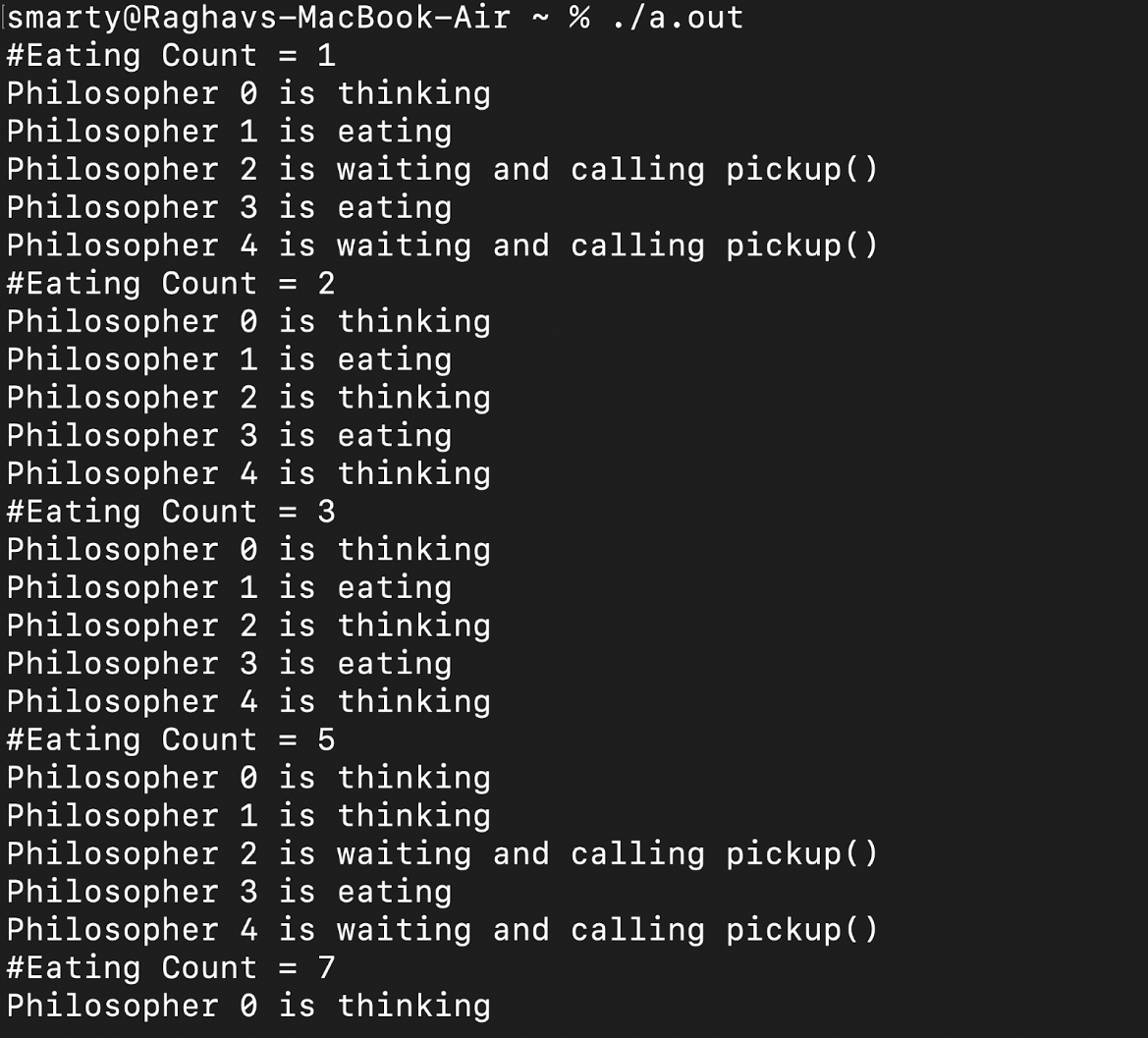

**REFERENCES:**

**[1] “Dining Philosopher Problem Using Semaphores - GeeksforGeeks.” *GeeksforGeeks*, 13 Nov. 2017, www.geeksforgeeks.org/dining-philosopher-problem-using-semaphores.**

**[2]“Dining Philosophers Problem (DPP).” *Dining Philosophers Problem (DPP)*, www.tutorialspoint.com/dining-philosophers-problem-dpp. Accessed 19 Dec. 2022.**

***[3]https://pages.mtu.edu/~shene/NSF-3/e-Book/MUTEX/TM-example-philos-1.html*. pages.mtu.edu/~shene/NSF-3/e-Book/MUTEX/TM-example-philos-1.html. Accessed 12 Jan. 2023.**

**[4]“Dining Philosophers Problem (DPP)-Algorithm”**

**Pankaj Nandan and Charanjeet Singh. “Fundamentals of Operating Systems.” *Dining Philosophers Problem (DPP)-Algorithm*, Second Edition, 2017, p. 6.10.3.**

**[5] “Agent Based Solution for Dining Philosophers Problem.” *Agent Based Solution for Dining Philosophers Problem | IEEE Conference Publication | IEEE Xplore*, ieeexplore.ieee.org/document/8286072. Accessed 19 Dec. 2022.**

**[6]“Dining Philosophers Problem - Wikipedia.” *Dining Philosophers Problem - Wikipedia*, en.wikipedia.org/wiki/Dining_philosophers_problem. Accessed 12 Jan. 2023.**